Upgrade Oracle 12.2 to Oracle 19.3.0 using AutoUpgrade method_Change Service-Name
step1. Take a full backup plus archivelog of the source db, 12.2 database and controlfile
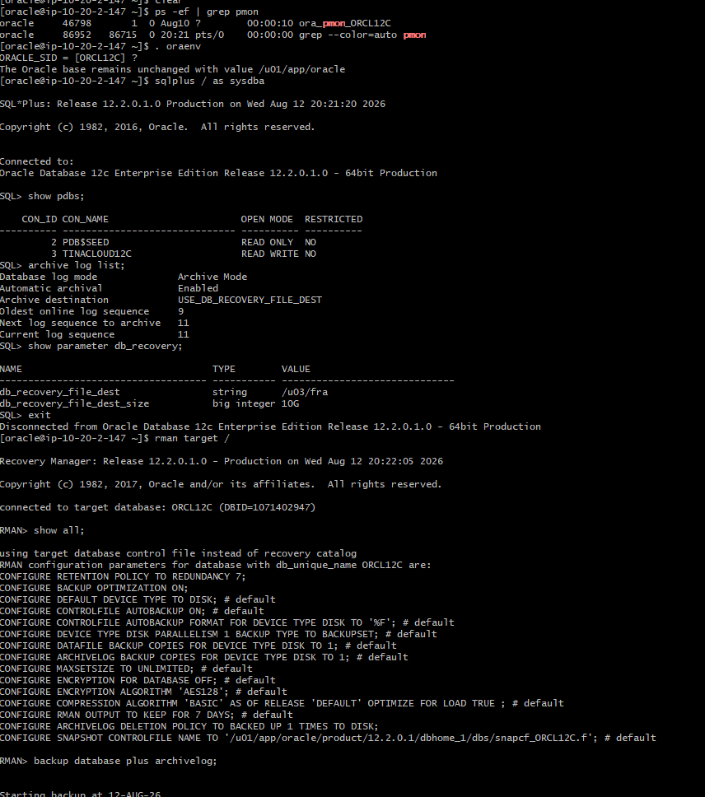

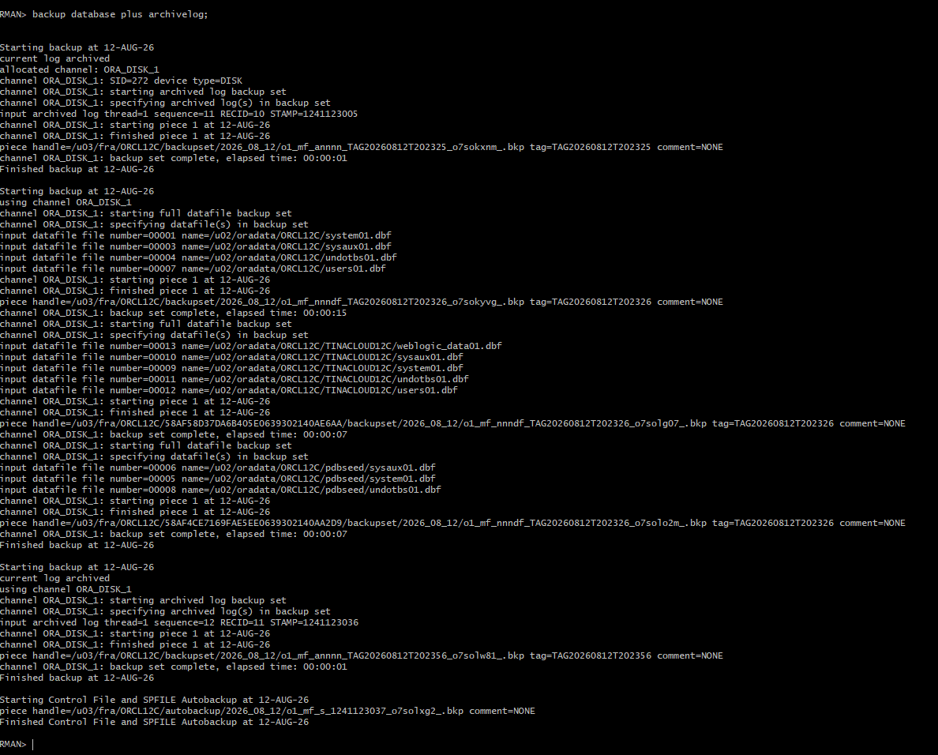
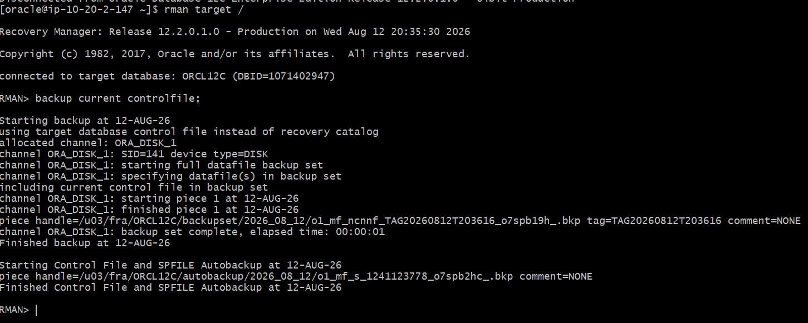

2. Verify compatibility of 12.2 database and make sure db_recovery_size is atleast 20gb
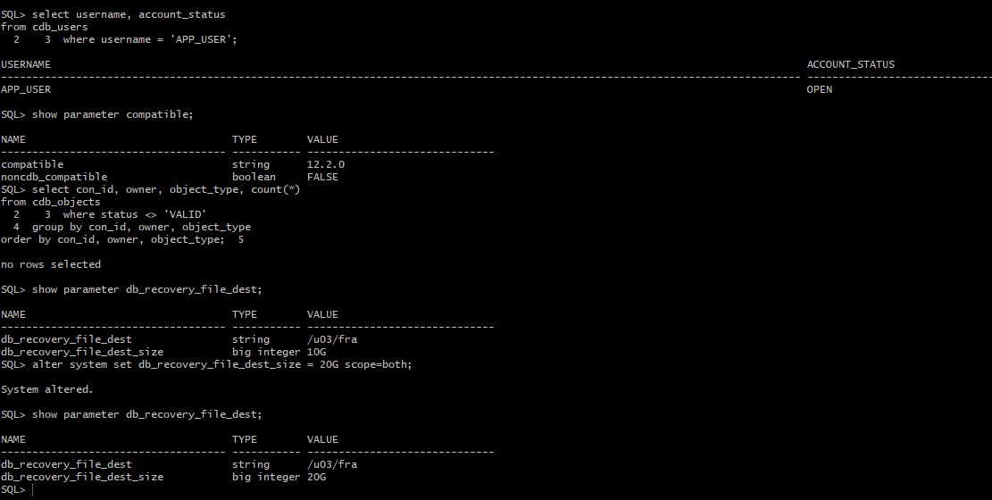
3. Create 19.3.0 home and unzip 19c software on the 19.3.0 home
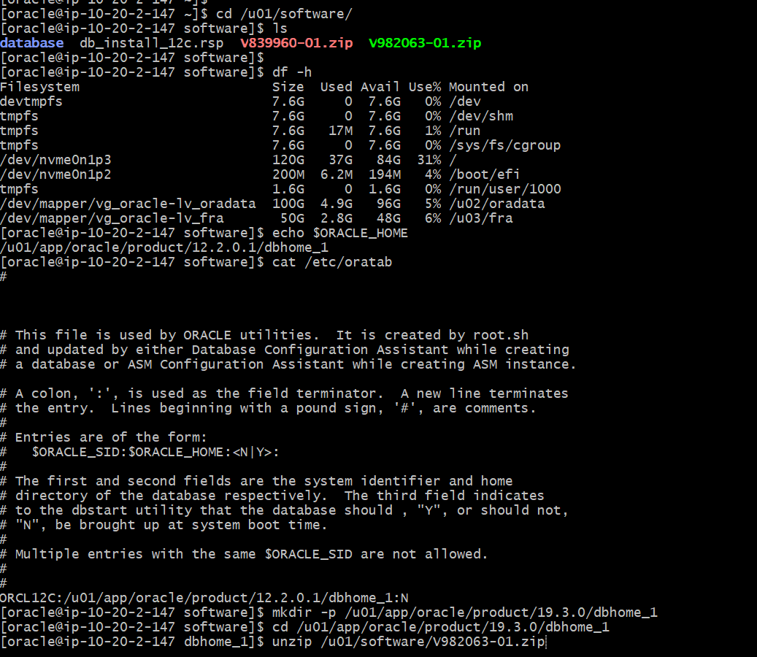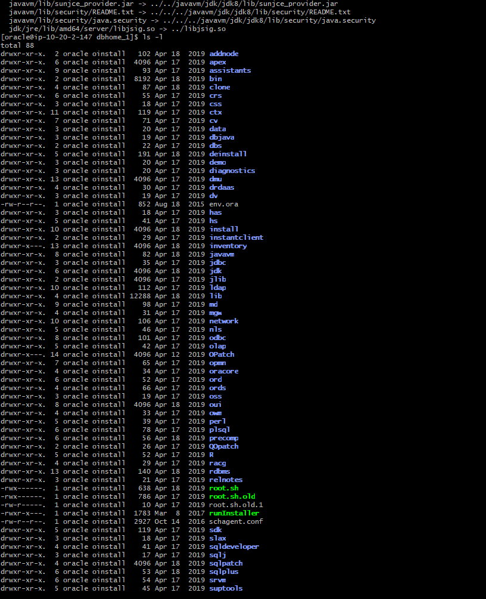

Execute ./runinstaller to download oracle binaries in 19.30 ORACLE_HOME.
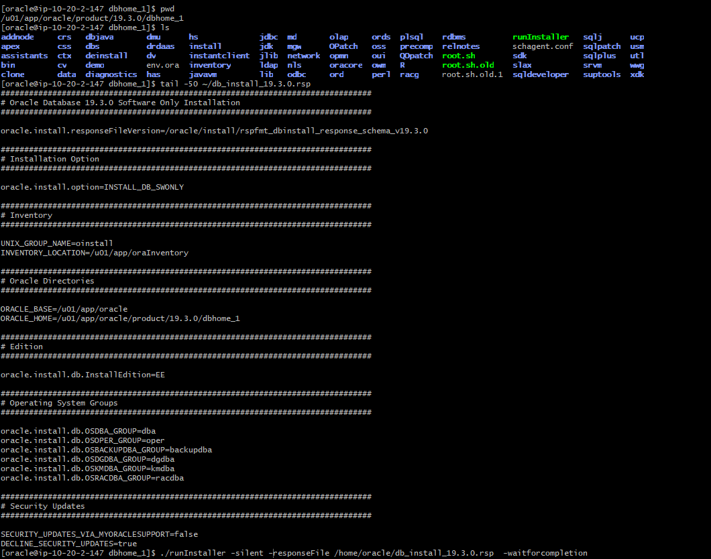

Export 19.3.0 environmental variables so 19.3.0 can become available in Oracle inventory
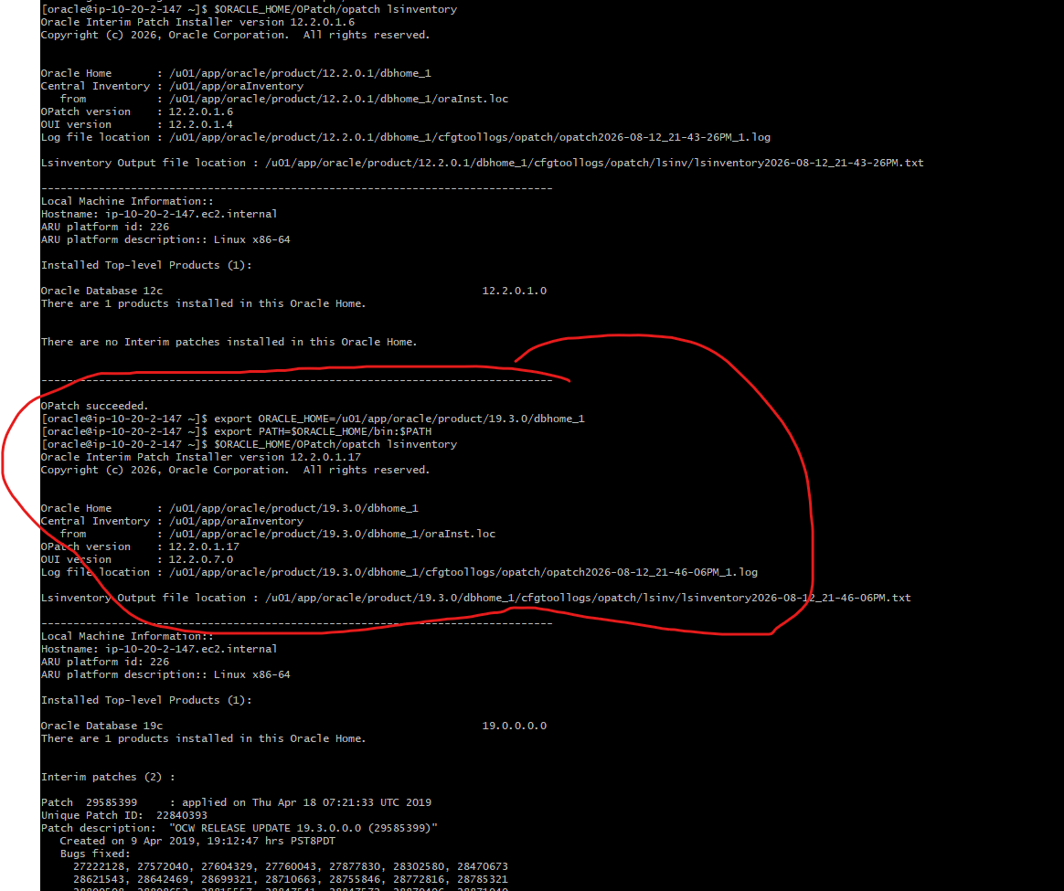
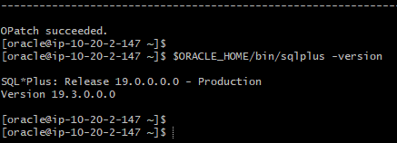
Stop database and listener to begin patching:
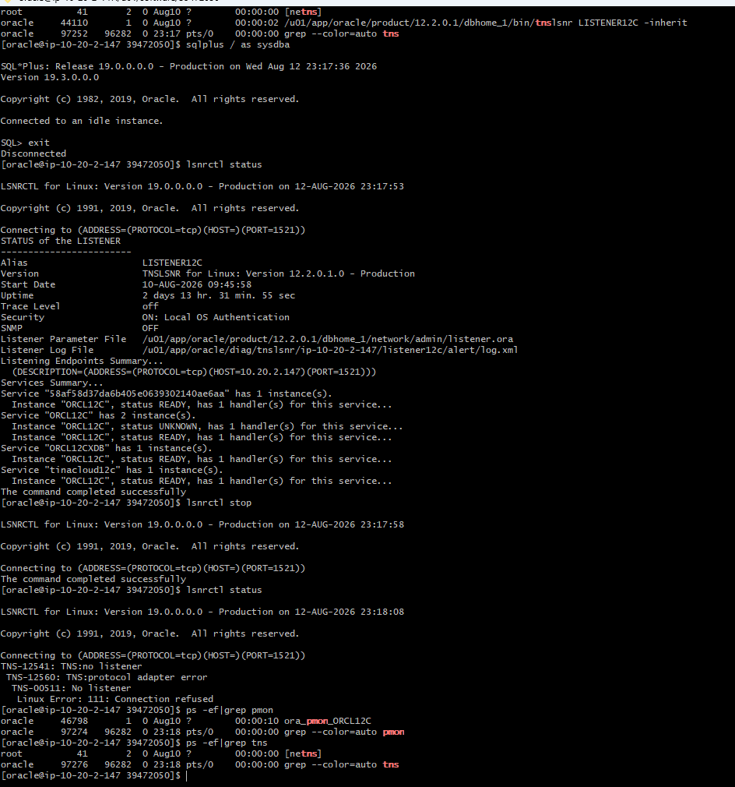

Unzip Opatch zip file in 19.3.0 home to upgrade opatch version
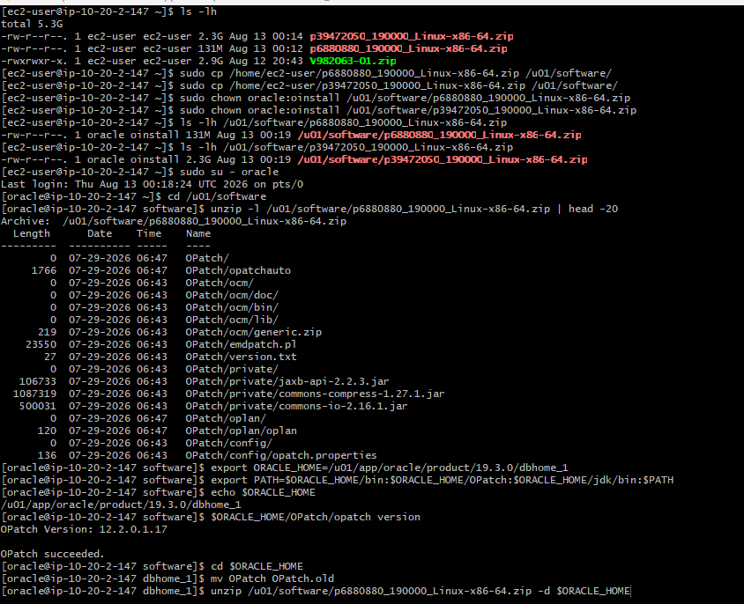and verify opatch has been successfully upgraded.
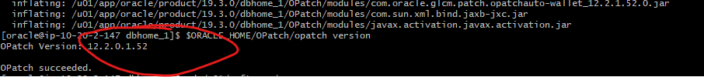

Unzip July 2026 CPU and use opatch to apply to Oracle home
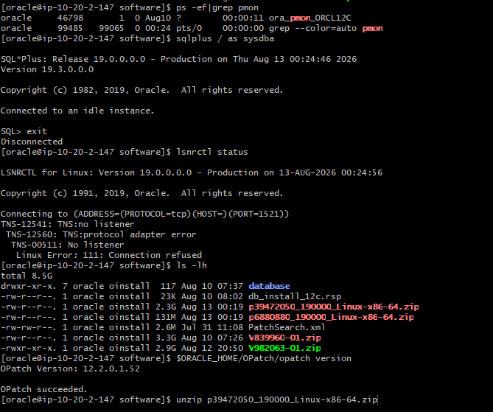
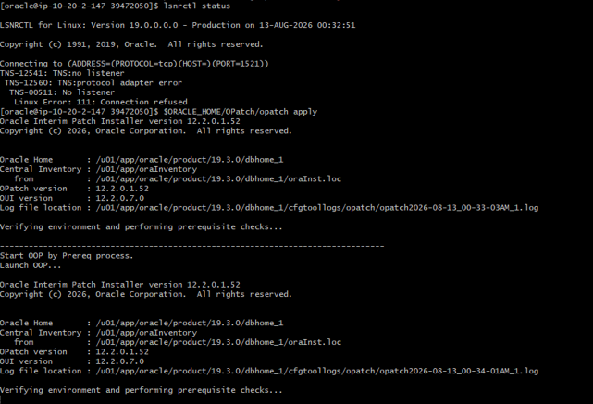
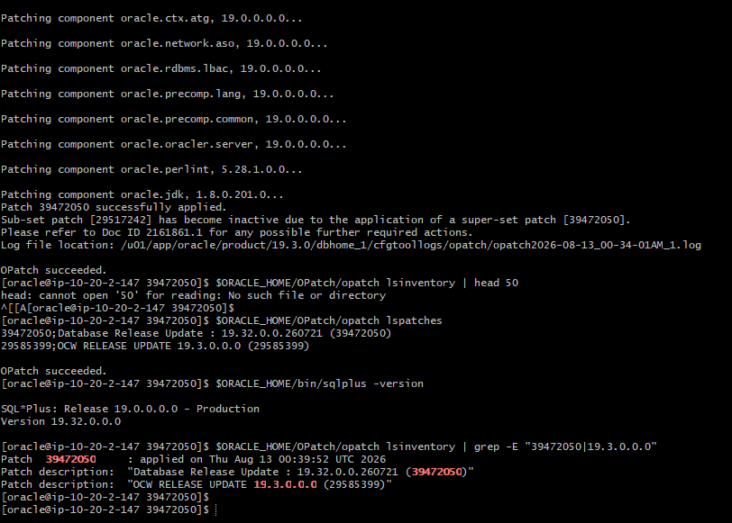

Start upgrade
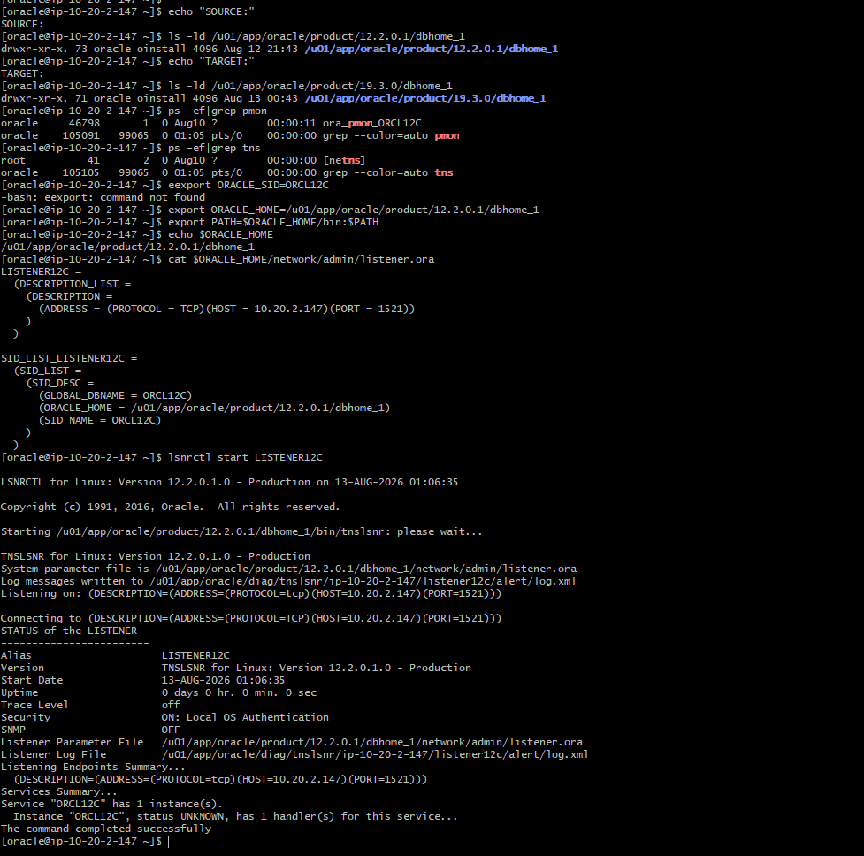
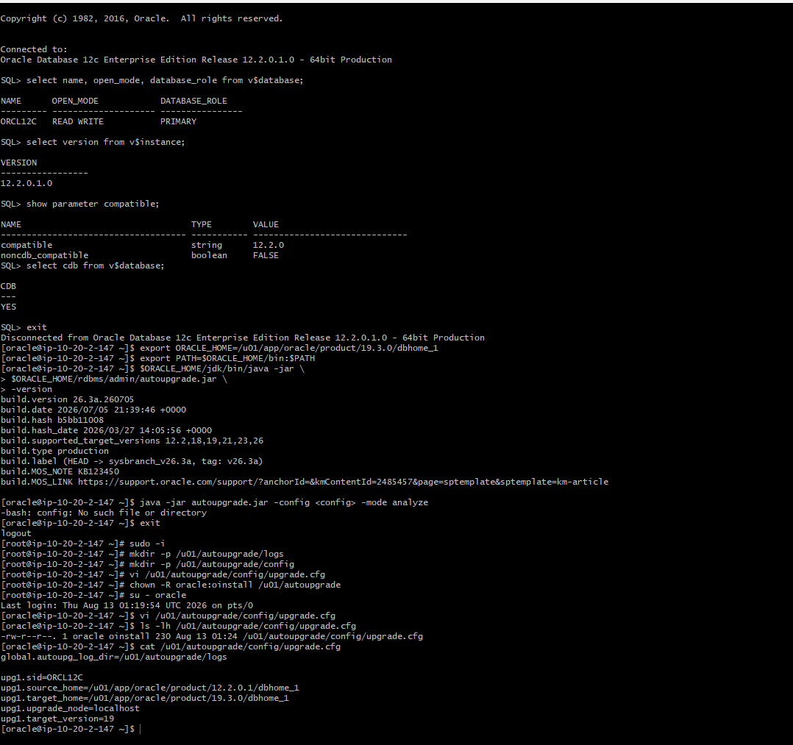

Analyze source database for upgrade blockers (invalid objects, tablespace, storage considerations, upgrade scripts and fixups0
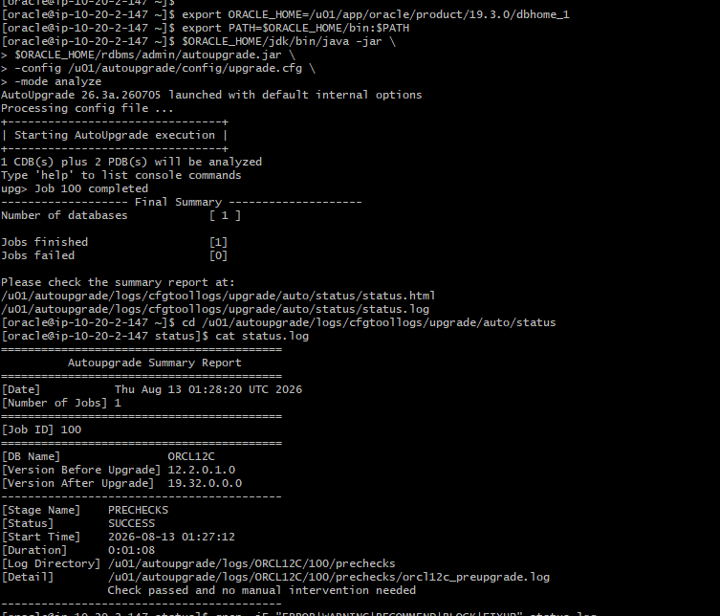
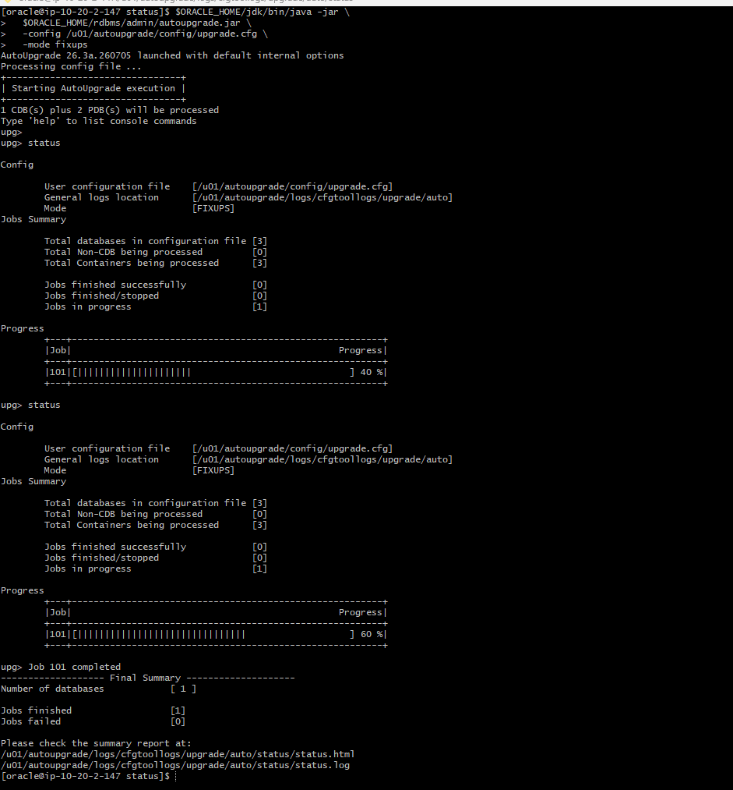

Start autoUpgrade deployment:
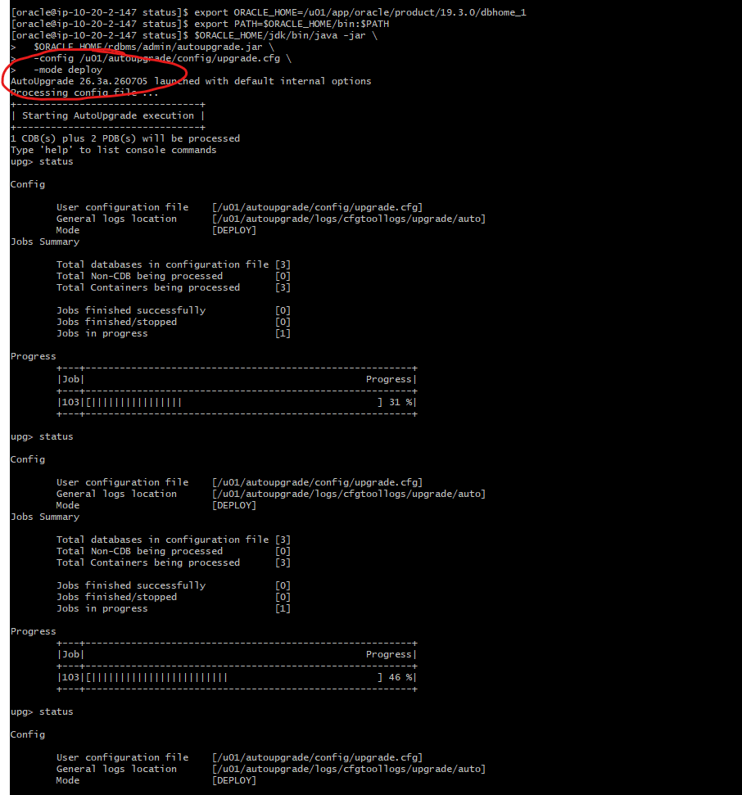

19.32 Upgrade completed successfully:
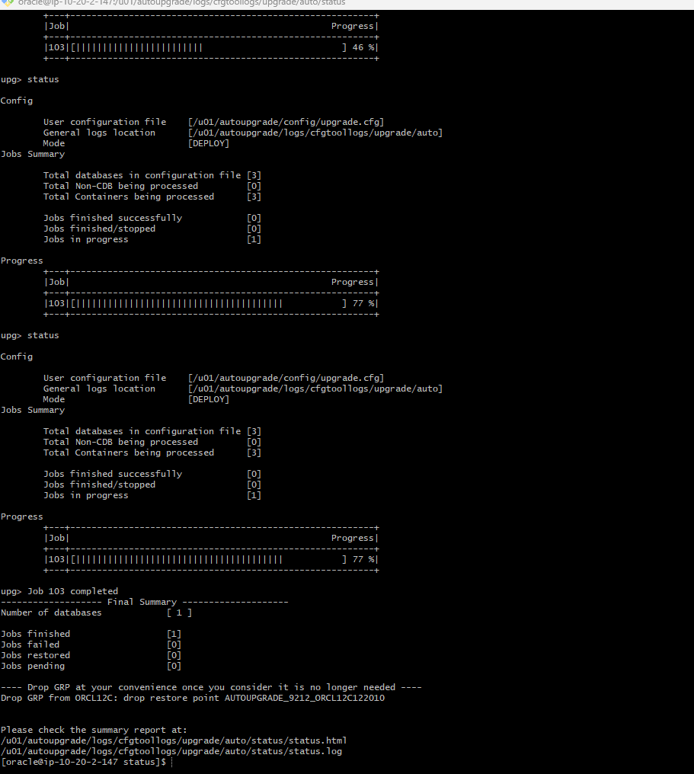

Verify that database version is new version 19.32.0
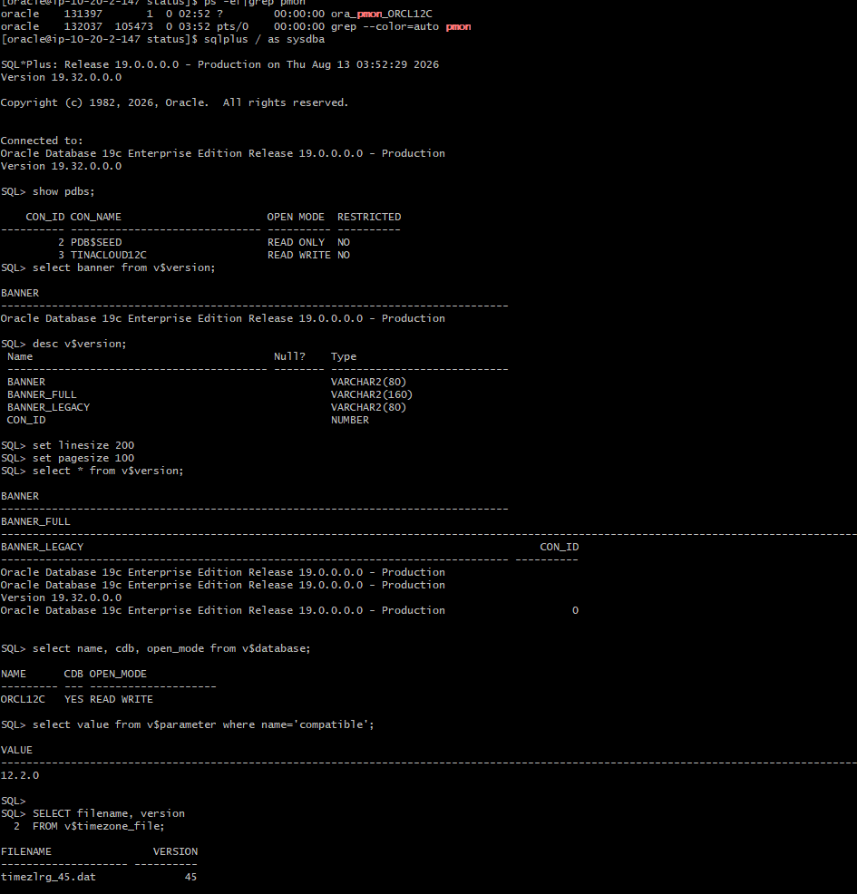
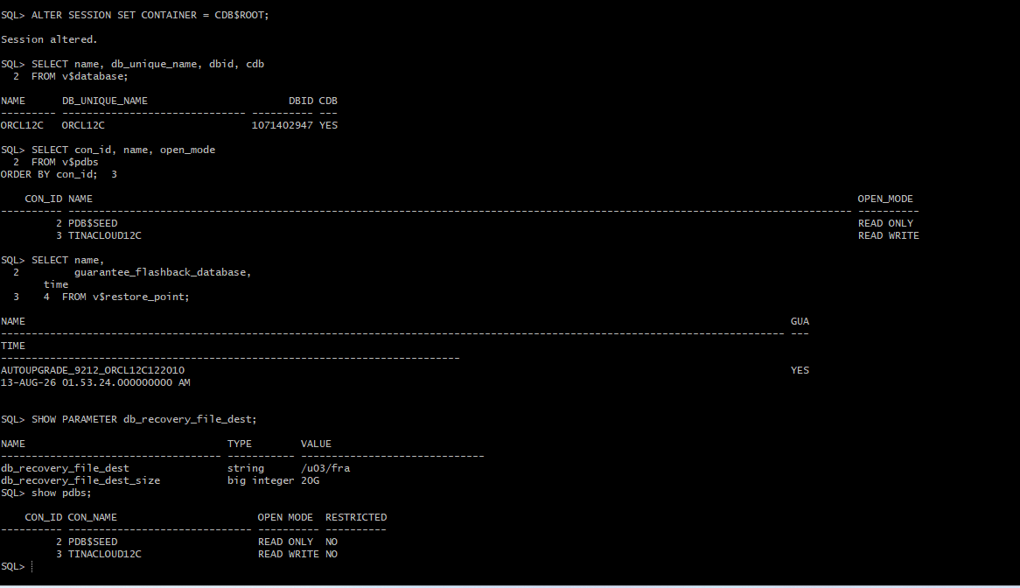

Verify timezone file for 19.3
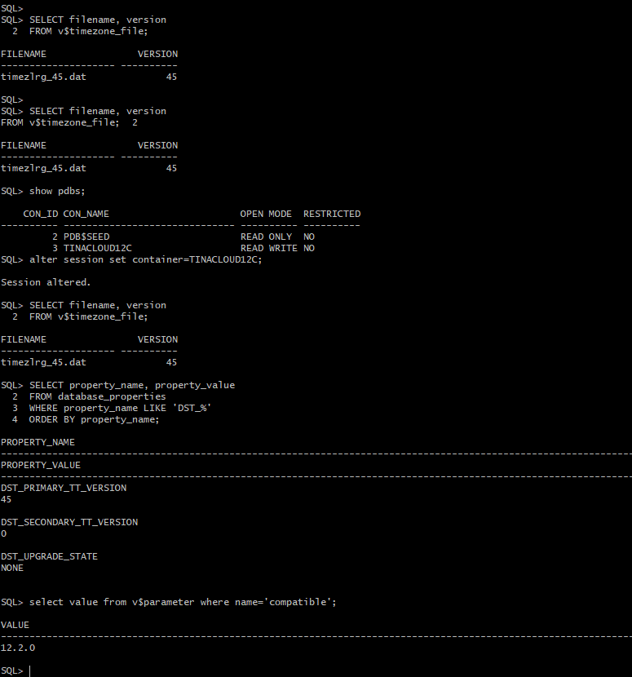
Change database name and PDB (Service) names:
Validate you have a restore point before you begin to change CDB and PDB names.
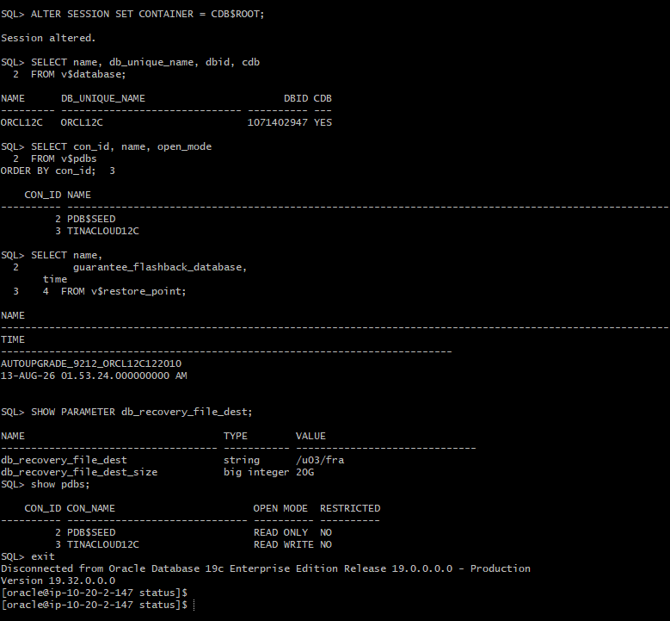
Bring down site to rename Service name and PDB:
Stop managed server:
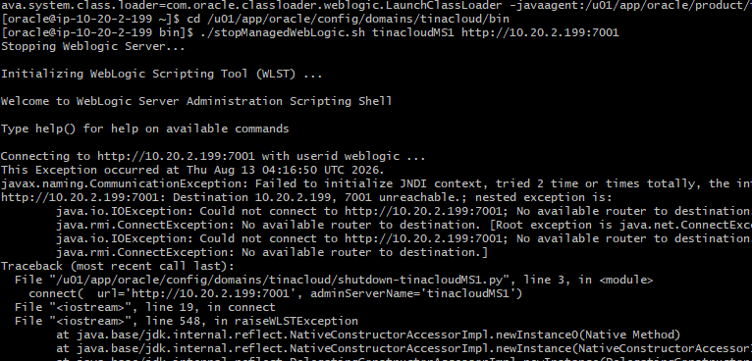
Stop Admin server and nodeManager: 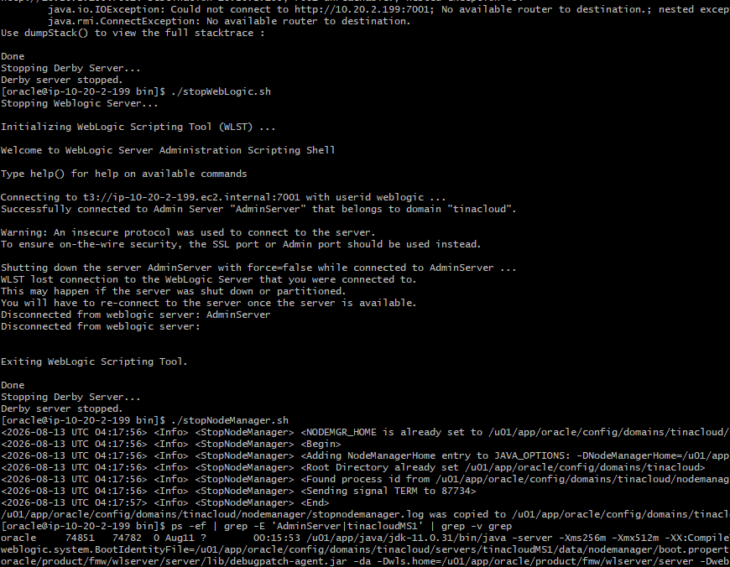
Verify all the app services are down:
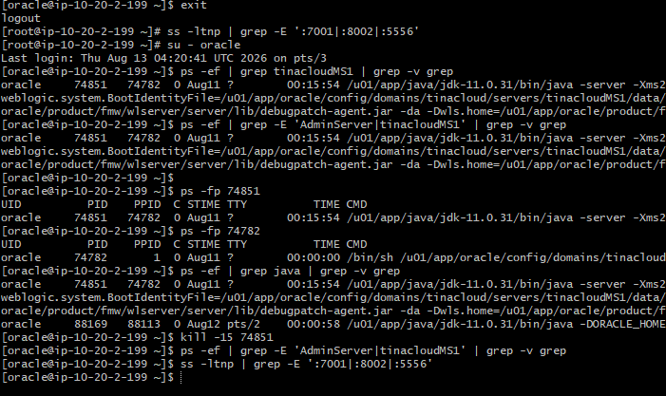

Change database name using NID utility:
name successfully changed from ORCL12C to TINACDB
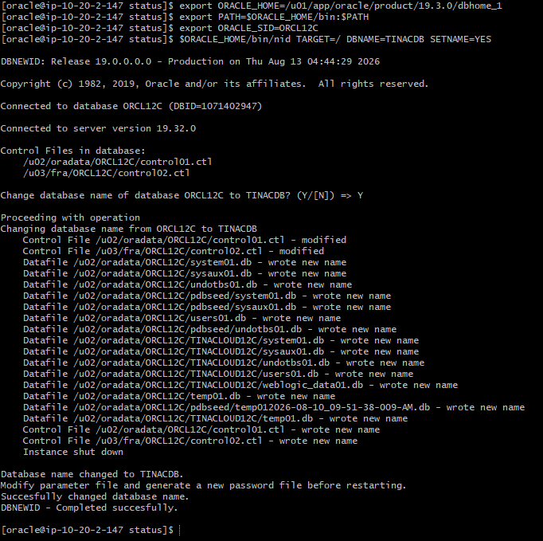

-Update pfile with new service name
-Take a backup of spfile
Create new spfile using the updated pfile
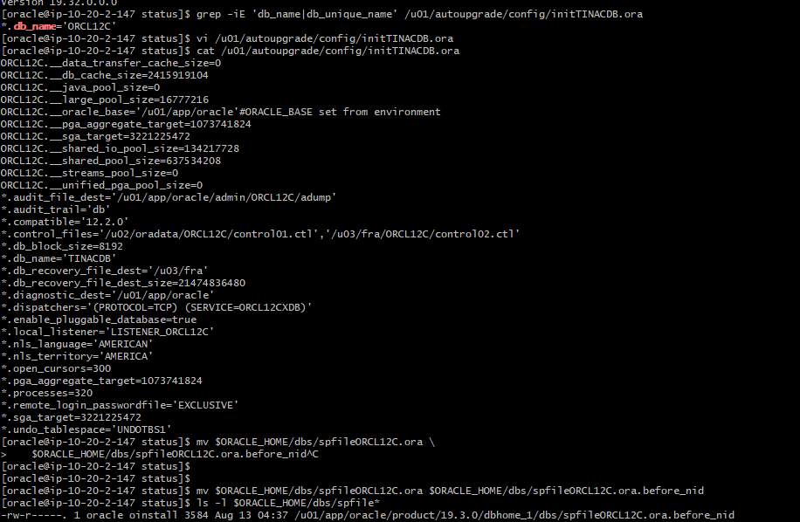
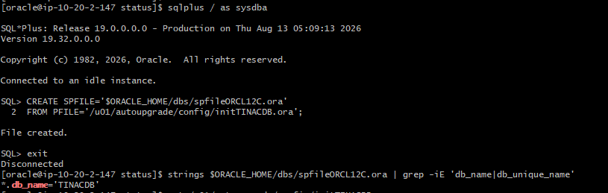
Change pdb (service) name:
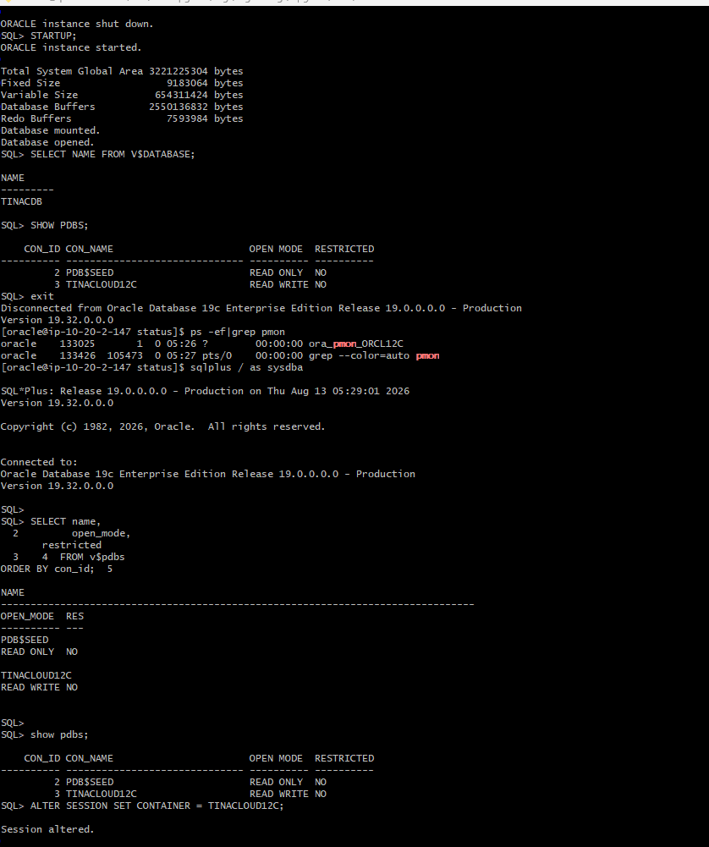
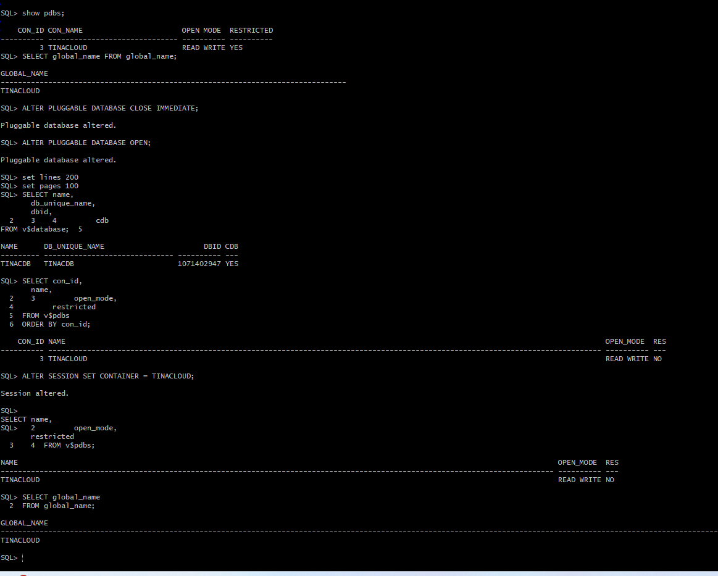
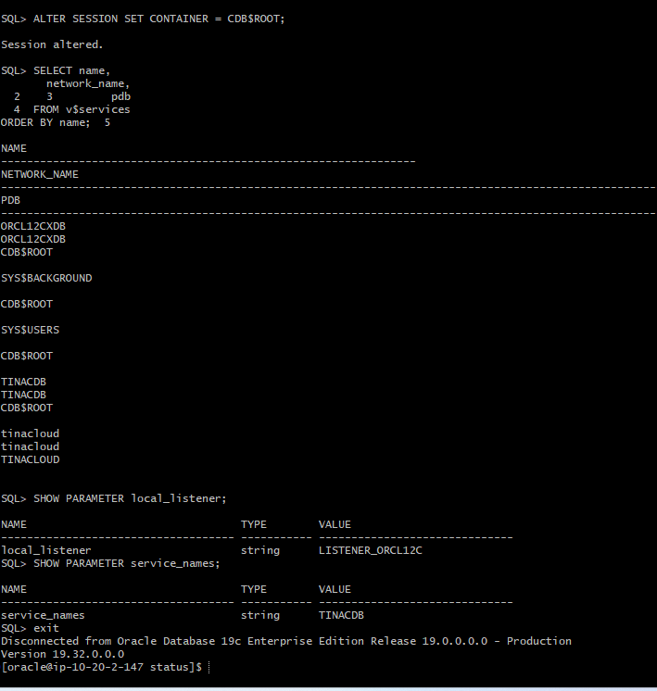
Take a backup of the listener and tnsnames.ora file and

Update tnsnames.ora with new service name and database name entries
